Task 2 – Design Brief

Specifications and Requirements

Target Platform

The target device for my game will be the Computer platform targeting Windows operating system.

The resolution will be targeted for a 16:9 aspect ratio but settings will be available to adjust according to screen size, even though the game will be full screen mode. These settings would fix scalability issues.

The game will be used through a build which consist of an executable file.

Controls and Mechanics

The controls of the game will consist of the ‘A’ and ‘D’ and maybe in the future implement another key, but mainly these keys will be used to go to the left and right.

The mechanics of the game will simply be the trimming over the stack, stacking and dodging obstacles through the use of the ‘A’ and ‘D’ keys

Score system which tracks the placement of each block. This would gain the player a score with each stack.

High score system which takes the highest score and makes it the high score and would save it

Game Screens

The game will have a main menu consisting of the Instructions, Settings, High scores and Play buttons. These take you to their corresponding menus. Also a quit button will be included of course.

Settings menu will consist of a resolution, brightness, sound and color modes panels. Each of these panels will serve as a feature for the player to use.

The resolution will include a 16:9 and a 4:3 aspect ratio panels where you could use the main Resolutions that usually players use.

The brightness panel will include the brightness slider of course, adjusting the brightness of the game.

The sound panel will include a Master Volume and an Ambient slider.

Flow chart

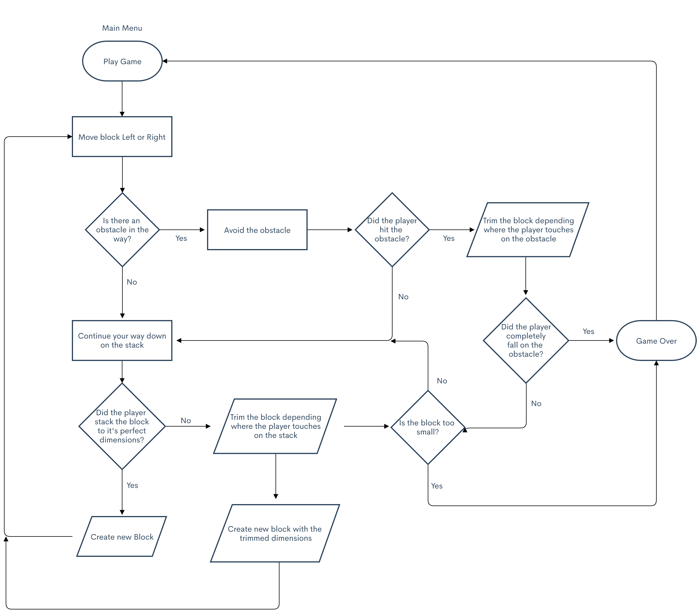

Game Objectives

The objective of the game is to place the block perfectly on the stack to maintain a big block so that you can go longer and longer, of course the game keeps on going indefinitely until you become small enough that the game ends, but maintaining the size allows to get a much bigger score.

The main objective is of course getting the highest score possible, but along the way you have to create strategies to avoid the obstacles.

Art Assets

The player’s block



The first stack block

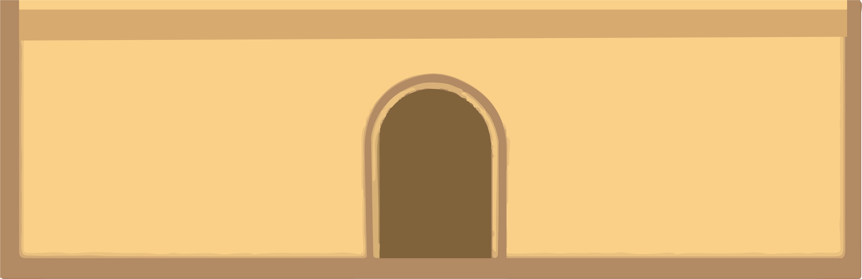

The obstacle



The background

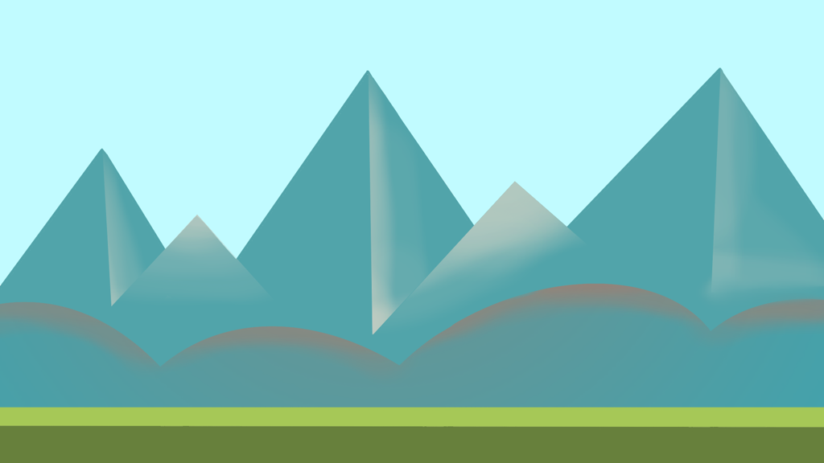

The Inspiration of how it originally was planned

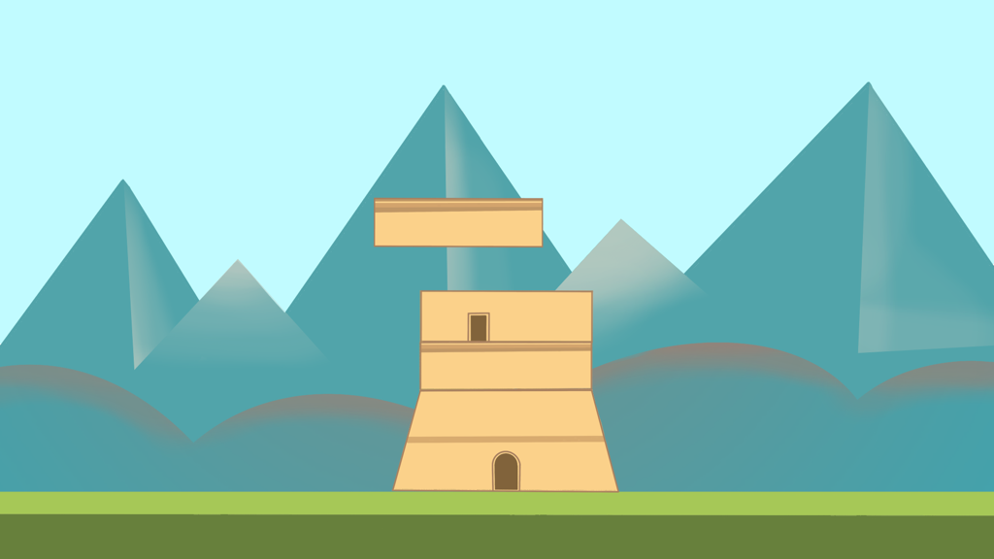

User Interface

The user interface will be very simple, resembling the most basic game’s GUI such as Terraria and other simplistic games, which menu is super easy to understand and is very user friendly.

The idea is to have a few buttons on the main menu, and a settings button which lead to a few useful settings, nothing redundant that only confuse the player and the user-flow.

Game over menu after losing the game having a separate menu from the game and add a back to the menu and a restart option, to restart the game.